CHAPTER THREE

SYSTEM DESIGN METHODOLOGY

3.1.0 INTRODUCTION
In this chapter, the system design methodology used in implementing this project is discussed. The system requirements specification will also be outlined in details in this chapter. It entails a detailed components specification of the system being provided by this project. More so, the system design in terms of logical design and physical design will be specified herein. The logical design consists of the various parts of the program and how they interact with each other, while the physical design, illustrates the program specification, type of data and its structure.

3.2.0 SYSTEM REQUIREMENTS SPECIFICATION
System requirements specification, is a structured outline of the system requirement information. It states the functional and non-functional requirements of the developed system and clearly states what the result of the project will be, and what the system should do. These are to be determined by the objectives of the project.
This section is focused on the functional requirements of the proposed model.

3.2.1 FUNCTIONAL REQUIREMENTS
- The result of this project should be a trained machine learning model.
- The dataset used must be in the appropriate form for best result. (The best form data can be for machine learning differs with purpose. For example, a data set that contains a complete date, will need to be truncated to say, only the hour of date if that is what is necessary for the particular learning. Data that categorize people as female and male would be converted to scale e.g. 0 for male and 1 for female), Brownlee (2015).
- The trained model should be able to predict with the highest possible accuracy, the likelihood of having a heart disease in an individual, given the right symptoms data.
- The result of the prediction should be represented by:
- 1 (one) indicating the presence of heart disease
OR
- 0 (zero) indicating the absence of heart disease.

3.3.0 SYSTEM DESIGN
This section explains the concept of how the system is designed in terms of architecture, components and data, to satisfy the specified requirements. This would help a user or researcher to understand the intricacies of the prediction model.

3.3.1 LOGICAL DESIGN
This section describes the abstraction of the structure and features of the prediction model from the various parts of the system such as input and output.

3.3.1.1 USE CASE
A typical use case is one where a patient in a hospital is tested and the result of this test is passed to a program that uses the machine learning model to predict the patient’s heart disease status. This is a step forward from expert systems, based on the accuracy of the results.

Input User Data

Trained Machine Learning Model

View Predicted Result

Doctor/Patients/User

Machine learning powered diagnostic system
Fig 3.1 Use Case diagram for the Machine Learning System

3.3.1.2 ACTIVITY DIAGRAM
Activity diagram illustrates the dynamic nature of the system. It shows how the process of cleaning up the dataset, from dividing the dataset into training and test set, to training the machine-learning algorithm and therefore achieving a model capable prediction of new set of data.

Start
Rectify invalid entry
Check for null or invalid data entry
Load dataset

Divide data into training and test set.

Select algorithm for training

Train the machine learning algorithm

Test the machine-learning model with the test data

Calculate the accuracy of the trained model.

Select the model with the highest accuracy.

Stop

FIG. 3.2 ACTIVITY OF A MACHINE LEARNING TRAINING PROCESS.

3.3.2 PHYSICAL DESIGN
Physical Design of the system specifies the internal structure of the system. Here, the actual design implementation is demonstrated.

3.3.2.1 PROGRAM SPECIFICATION
The program specification describes the actual logic of the program execution. It defines how the overall system works.
LoadData(“/path/to/training/data”);
ValidateData();
If (!valid) {
Delete invalid data or replace with valid data;
}
Divide data into training and test data;
Algorithm = InsantiateAlgorithm(necessary parameters);
// Train Algorithm:
TrainedModel = Algorithm.Train(TraingingData, TraingingAnswers)
// Test Model:
Prediction = TrainedModel.Predict(TestData)
Compare prediction to TestAnswers
AccuracyOfModel = Percentage of correct prediction;

3.3.2.2 DATA DESIGN
This shows the dataset table used in the project. This dataset was gotten from the UCI machine learning repository in a CSV format, which is then converted into a pandas data frame and displayed below.
Table 3.1: FIRST 20 ELEMENT IN THE PROCESSED DATASET (Aha, 2016)
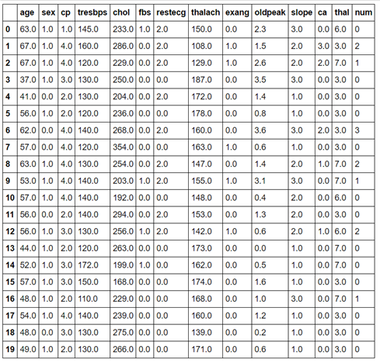
The table below describes the dataset used in this project. Each column of the data frame is described in detail and the expected values are illustrated.
Table 3.2: LAYOUT OF THE DATASET
FIELD NAME | DESCRIPTION | VALUES
Age | Age
Sex | Sex | 1 = male, 0 = female
Cp | Chest Pain type | Value 1: typical Angina  Value 2: atypical angina  Value 3: non-anginal pain  Value 4: Asymptomatic
Tresbps: resting blood pressure(in mmHg on admission to the hospital) | resting blood pressure | in mmHg on admission to the hospital
Chol | serum cholesterol | in mg/dl
Fbs | fasting blood sugar > 120 mg/dl | 1 = true; 0 = false
Restecg | resting electrocardiographic results | Value 0: Normal  Value 1: Having ST-T wave abnormality  Value 2: Showing probable or definite left ventricular hypertrophy by Este’s criteria
Thalac | Maximum heart rate achieved.
Exang | Exercise induced angina | 1 = yes, 0 = no
Oldpeak | ST depression induced by exercise relative to rest.
Slope | The slope of the peak exercise ST segment. | Value 1: upsloping  Value 2: flat  Value 3: Down sloping
Ca | Number of major vessels (0-3) colored by flourosopy | 0 – 3
Thal | Heart rate | 3 = normal; 6 = fixed defect; 7 = reversible defect.
num | Diagnosis of heart disease | 1 = presence of heart disease.  0 = absence of heart disease.

Approved as modified. You may proceed to Chapter Four. However, I can only consider your Chapter Four, after seeing your running code.

